Contemporary philosophy|Book Review

The truth is out there

Do different perspectives lead to scientific progress?

By David Papineau

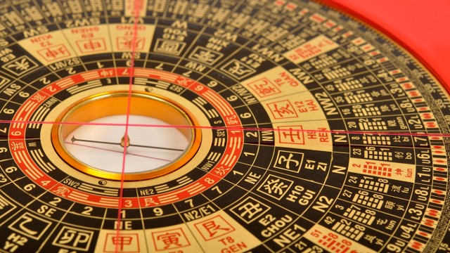
A Chinese geomantic compass|© red_green_blue/Getty Images

PERSPECTIVAL REALISM
416pp. Oxford University Press. £64.
Michela Massimi

Does science tell us how things really are? Most people in the modern world would probably answer yes. The academics who analyse the workings of science, though, are not so sure. For a start philosophers of science point out that science isn’t easy. It’s not just a matter of conquering superstition and conducting experiments. Scientists need to conjure up complex hypotheses and tease out their implications. Decisive experiments are rare. In the eyes of the philosophers, the frequent overthrow of widely accepted theories is a demonstration of the fragility of scientific findings.
Many sociologists and historians of science go further. They take the view that, since the facts by no means force themselves on scientists, other influences are often responsible for their opinions. Studies of scientific institutions show how successful scientists build up networks of influence and use them to promulgate their favoured views. Support from the world outside science is, moreover, rarely disinterested. Funding flows more readily to work that promises to bolster commercial and political interests than to work that undermines them. Claims to scientific truth, urged Michel Foucault, can never be separated from the structures of power that lie behind them.
By the end of the twentieth century these misgivings had largely become orthodoxy among the academics who study science. Since then, however, there has been a sea change. A few clever commentators started remarking on the uncomfortable affinity between the views of the science studies academics and those of climate-change deniers, creationists and anti-vaxxers. Weren’t these deplorable anti-science factions simply repeating the academics’ message that orthodox science is always tailored to the interests of the establishment? The professional students of science quickly back- pedalled. That’s not what we meant at all, they explained. We just wanted to show how science is complicated, not to undermine the authority of right-thinking scientists. In 2004 Bruno Latour, whose earlier work had pioneered the social analysis of science, recanted publicly, disavowing any idea that his work served to discredit the truth of scientific claims.
Michela Massimi’s Perspectival Realism lies squarely in this tradition of science studies. As her title indicates, she recognizes that different communities of scientists will bring different assumptions and interests to bear on any given scientific topic. But, unlike the earlier generations of science scholars, she does not infer that accepted theories are just an expression of sectional bias. Precisely because different scientists adopt different perspectives, she argues, they can triangulate on the truth. As she explains on her first page, her aim is to uphold the authority of science, not to query it.
“My original motivations for writing this book were fairly simple … I have always been of the view that a realist stance on science offered a safeguard to a society where trust in science was being eroded before our eyes. I watched with apprehension … anti-vaccine movements gaining traction among the public; international talks on climate change breaking down … and scientists forced to take to the streets and march for science.”
In the first half of this expansive book Massimi uses three extended examples from different areas of science to illustrate her main thesis: the structure of the atomic nucleus, projections of global climate change and dyslexia in reading development. These studies are all fascinating in their own right, and in each case she is able to show how the divergent approaches of different scientific groups played a crucial role in uncovering the truth. This attention to scientific detail continues into the second half of the book, where Massimi argues that the classifications highlighted by scientists, while answering to real features of nature, also reflect human concerns, citing in support material from calorimetry, hydraulic engineering, genetics and cosmology, among many other fields.
On one central point, though, Massimi is surprisingly reticent. She doesn’t explain why we should be confident that the application of different perspectives will lead to the scientific truth. As she sees it, this is not her problem. She has no doubt that truth will out in science. “Questions of existence”, she assures us early in the book, “are best left to scientists.” Even so, many of her own examples call this conviction into question. In the course of the book she discusses a range of cases, from the phlogiston theory of chemistry to the caloric theory of heat, where theories supported by multiple perspectives later turned out to be misguided.
This worry is accentuated in the final chapter of the book, when Massimi seeks to enrol traditional thought into a big tent of scientific inclusivity. She argues for a “multiculturalism” that recognizes the importance of indigenous medicine and ancient technologies, urging that this is consistent with the “cosmopolitan” recognition that these diverse sources all offer access to a common underlying truth. One does not have to disagree to feel that something more needs saying. Yes, traditional thought contains many insights, and they should receive due recognition – Massimi makes a powerful case on both points, citing inter alia the development of magnetic compasses by ancient Chinese geomancers, and the Filipino herbal antecedents of the anti-cancer drug vinblastine – but this should not obscure the point that modern science, with its runaway successes in technology and medicine, is a highly distinctive and relatively recent phenomenon whose intellectual and institutional foundations were laid in Europe four centuries ago. Many other intellectual traditions in world history have been highly sophisticated and numerate, but none has produced anything comparable. There is room for debate about the crucial elements in this modern scientific revolution, but it is clear that it must rest on something more than different groups bringing divergent perspectives to bear on common problems.
This desire to know what makes for good science is scarcely an idle curiosity. Perhaps Massimi is right to suppose that in the long run science will always arrive at the truth (though one could challenge her optimism on various grounds). But in any case that is no help when living people need to make practical decisions in real time. All too often we stand in need of crucial information, yet consensus in the scientific community is not always a sure guide. I am certainly persuaded that climate change is real and that anxieties about mainstream vaccines are misplaced. But what are we supposed to think about the influence of eating fat on obesity, or the role of lowered serotonin in depression, or indeed the efficacy of lockdowns in halting the spread of pandemics? These are all recent cases where the majority of the scientific community spoke with one voice, yet serious critics accused them of overegging the evidence and pandering to extra-scientific pressures.
It is hard to avoid the thought that Massimi, along with the rest of the science studies community, is in danger of throwing the critical baby out with the relativist bathwater. Nobody should regret the passing of the absurd view that science contains nothing but stories designed to serve the interests of the powerful. Modern science has, of course, uncovered myriad objective and important truths. But a blind faith in all claims endorsed by scientists would be just as bad. The climate-change deniers may have things dangerously wrong, but that doesn’t mean that the enthusiasms of the scientific community are never grounded in a commitment to establishment orthodoxy. If the students of science are now prepared to accord unlimited authority to anybody who sports a white laboratory coat, they will be doing science itself a disservice and adding weight to the suspicions of those who feel they’ve had enough of experts. Respect for scientists needs to rest on their doing good science, and it would be nice if the science studies academics could tell us what that is.
David Papineau’s most recent book is The Metaphysics of Sensory Experience, 2021

