By David Papineau
Oct. 28, 2021 5:59 pm ET

Games People Played: A Global History of Sports
By Wray Vamplew
Reaktion

Sports would count for nothing without history. Tradition is the only thing that raises athletics above idle pastime. Tiger Woods may be good at hitting a tiny ball into a little hole, but his significance to the game is measured by the long line of golfing heroes before him, stretching back past Jack Nicklaus and Arnold Palmer, through Walter Hagen and Bobby Jones, all the way to Young and Old Tom Morris in Scotland in the late 19th century. In boxing, we not only have the official title holder, but also the lineal champion—the man who beat the man who beat the man, going back to the first undisputed conquerors of the sport. The point applies across the board. The achievements of today’s star athletes are given meaning by our memories of their predecessors.
The present-day sport that claims one of the longest histories is sumo wrestling, as Wray Vamplew tells us in “Games People Played,” his comprehensive history of sports across the world. Some records suggest sumo contests were held as far back as 2,000 years ago; it was certainly a major part of Japanese culture by the ninth century. Of course, the Olympic Games are even older, but they have a gap in their story. First held in ancient Greece in 776 B.C., the Olympics continued every quadrennial for more than a millennium. But the Roman emperor Theodosius I closed them down around A.D. 394, and it was not until 1896 that the modern version of the games was revived in Athens. The way the modern games were explicitly modeled on the ancient ones itself testifies to the power of tradition. Without that background, a new international tournament of track and field and other assorted events wouldn’t have had the same resonance.
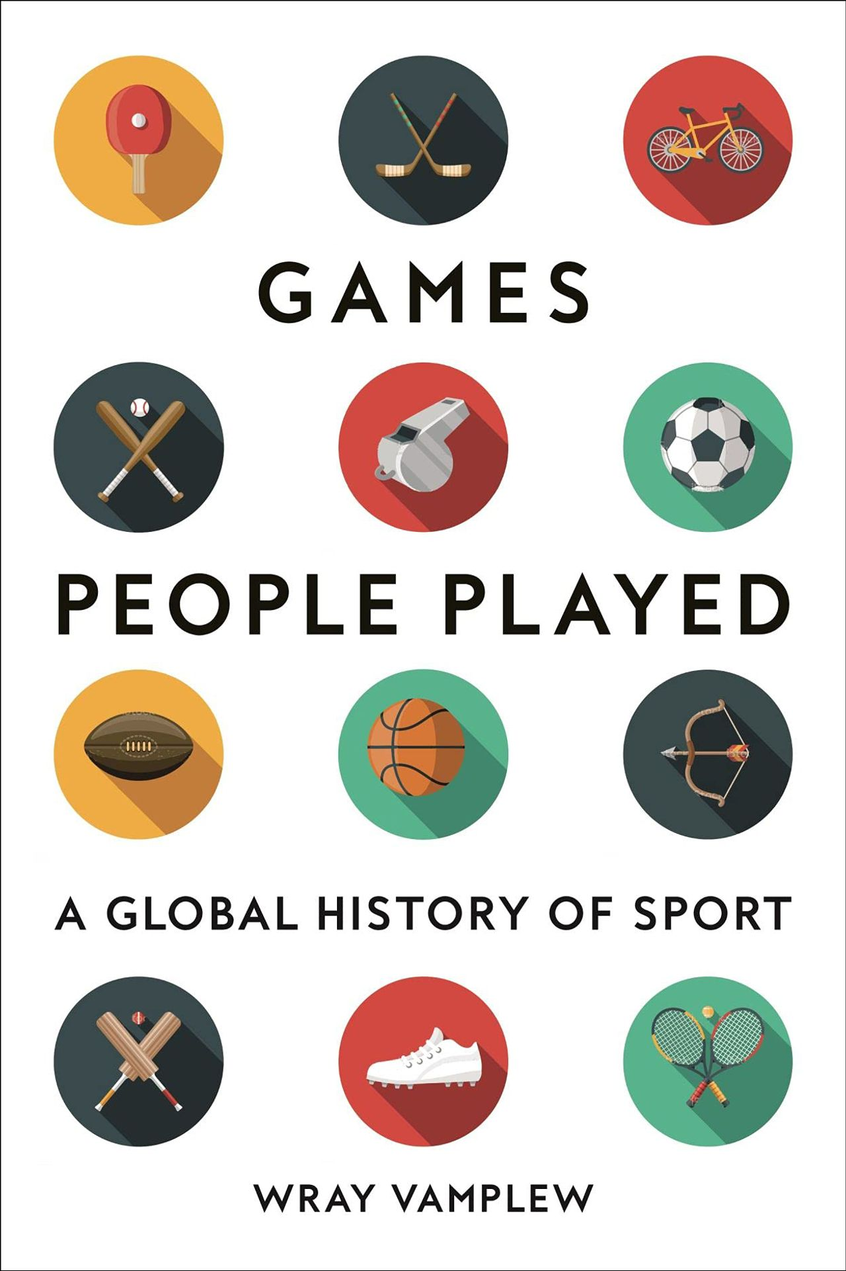
Perhaps it is unsurprising, given this need for history, that sporting traditions sometimes enter the realm of fabulation. Every four years the rugby-playing world competes for its world cup, the Webb Ellis trophy. The award is named after the schoolboy in Rugby, England, who is said to have first picked up the ball during a game of soccer in 1823 and so invented a new game. But, as Mr. Vamplew explains, the story is entirely bogus, with not a shred of evidence beyond some vague claims made by an old man 50 years later. Mr. Vamplew gives similarly short shrift to the idea that the Hall of Fame in Cooperstown, N.Y., marks the locale where Abner Doubleday invented baseball in 1839.
Sporting authorities often face a difficult balancing act when contemporary demands pull against traditional practices. Their natural tendency is to resist, but this can often spill over into irrational rigidity. The formats of baseball and golf have scarcely changed in more than a century, but the strength of modern players and advances in technology increasingly favor power over skill. Perhaps these games could learn from sports that have bent to the demands of the present. Cricket authorities have introduced shorter forms of the game alongside the traditional multiday contests, and in November billions of viewers will watch the world’s cricket-playing nations contest the Twenty20 World Cup in matches that last a mere three hours. Even the world of Japanese sumo has adapted to globalization and come to accept the influx of Hawaiians, Mongolians and East Europeans who now dominate the sport.
Mr. Vamplew, a professor emeritus of sports history at the University of Stirling in Scotland, is the author of many books, including “How the Game Was Played,” and was a co-editor of the six-volume “Cultural History of Sport.” “Games People Played” is the culmination of a life spent working on the history of sports, and it ranges far and wide. But sporting enthusiasts might feel there is something missing at its heart. There are few descriptions of sporting events as such. The book says far more about the surroundings of sports than the achievements of the athletes themselves. Mr. Vamplew is happy to allow, as he tells us on the first page, that sports can be a source “of personal fun and enjoyment.” But the task of good sports history, he explains, is to place sporting activity “in a wider social, political, economic or cultural environment.” By these lights, Mr. Vamplew is as informative and comprehensive as one could want. But the result can sometimes seem odd, like a book on art history that is excellent about the social standing of the artists and the cost of their materials, but tells you nothing about the paintings.
Perhaps part of the problem is Mr. Vamplew’s underlying attitude toward sporting activities. He says little about their intrinsic worth, beyond the possibility that they can be “personal fun.” To my mind, this radically undervalues the significance of sporting achievements. It is not an accident that lasting traditions have formed around all mainstream sports. For many people, sports go far beyond passing fun and enjoyment: They provide an arena in which humans can display unnatural levels of physical skill and mental resolve, and the results can be a source of both deep pride and utter disappointment. When Tiger Woods gritted his way round Torrey Pines on a fractured leg to win the 2008 U.S. Open, it was magnificent, but it certainly didn’t look like fun. Still, I suspect that most of Mr. Vamplew’s readers won’t need him to explain why sports are important, and beyond that he remains an outstanding guide to their role in history.
Mr. Papineau is a professor of philosophy at King’s College London and the City University of New York. He is the author of “Knowing the Score.”
Copyright ©2021 Dow Jones & Company, Inc. All Rights Reserved.
Appeared in the October 29, 2021, print edition as 'The Agony And the Ecstasy.'

